**DATA ANALYTICS ASSIGNMENT -1**

ALLAMUDI .YAMINI

VNITSW

4th B.Tech (CSE)

20NN1A0562

**BAR CHART:**

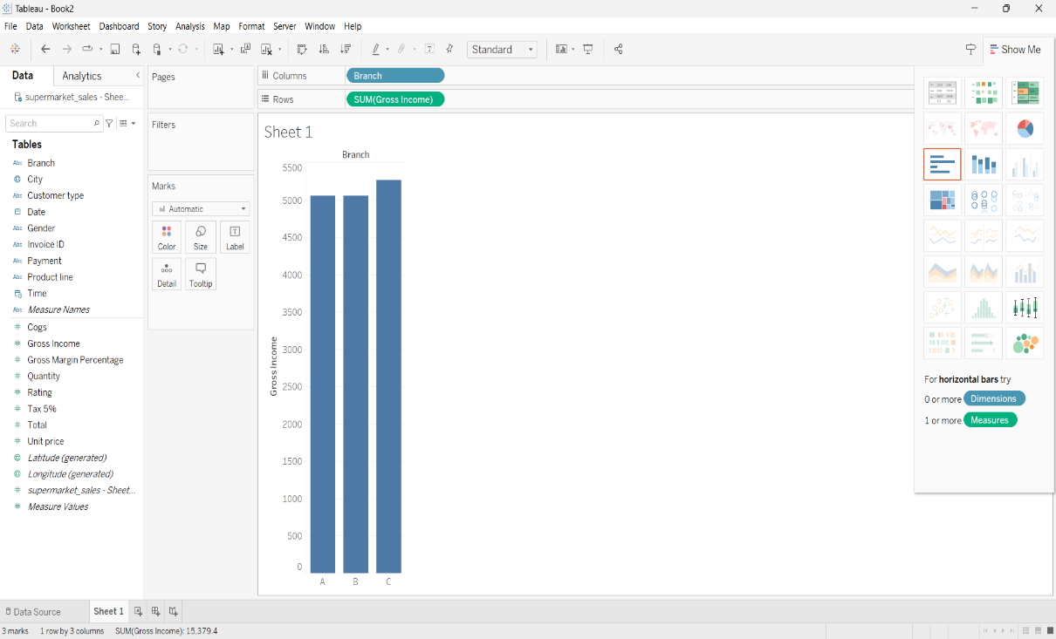

**PIE CHART:**

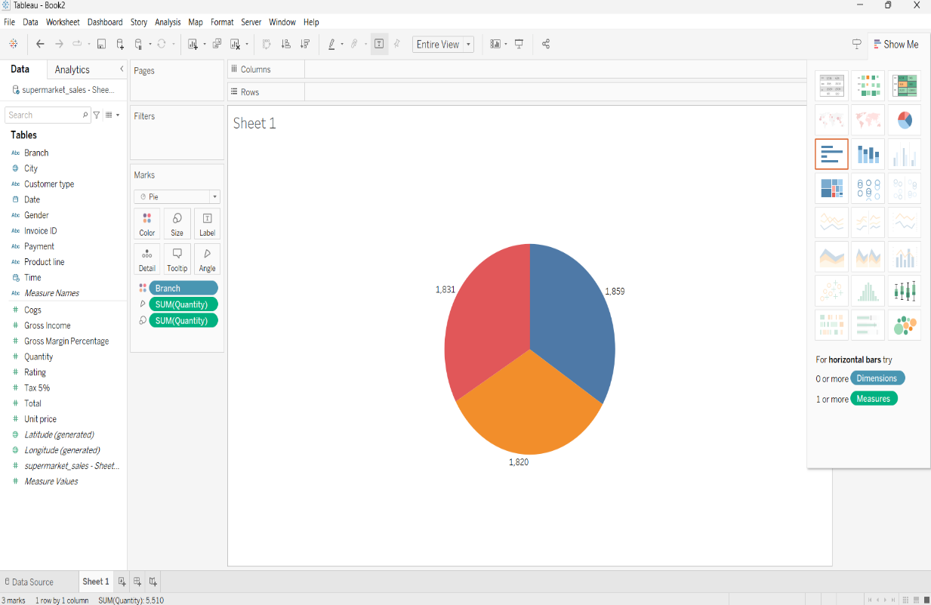

**STACKED BAR CHART:**

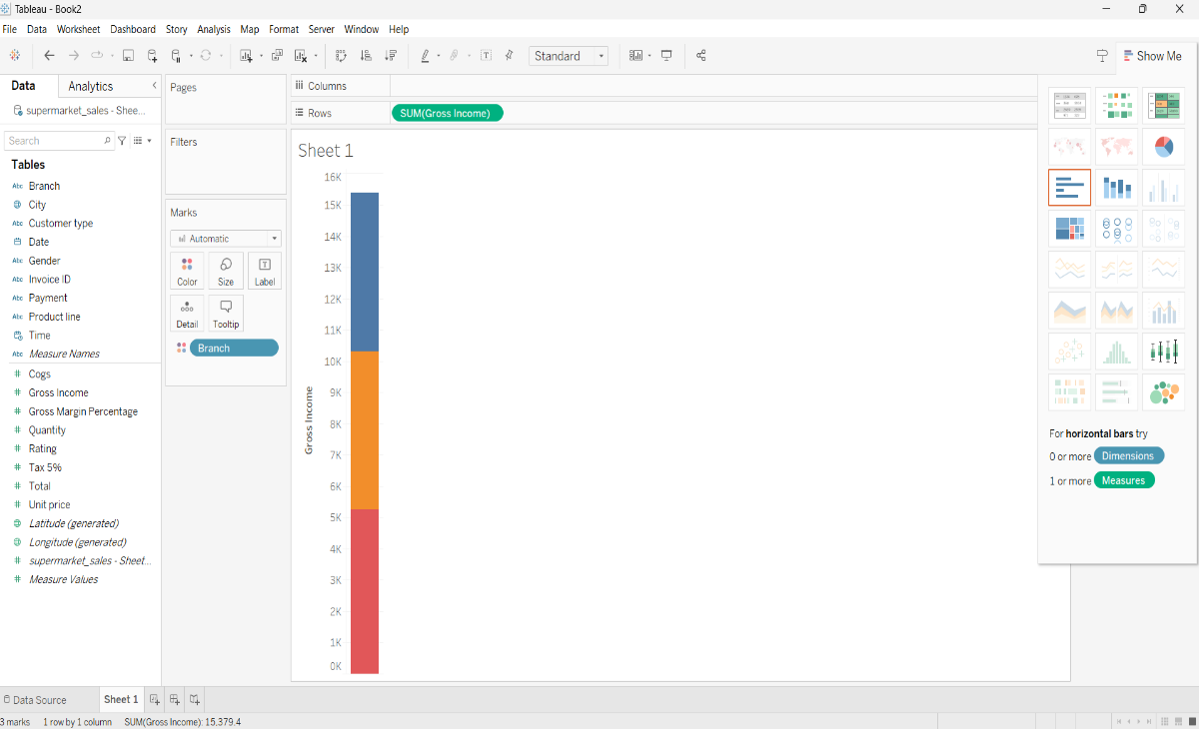

**LINE CHART:**

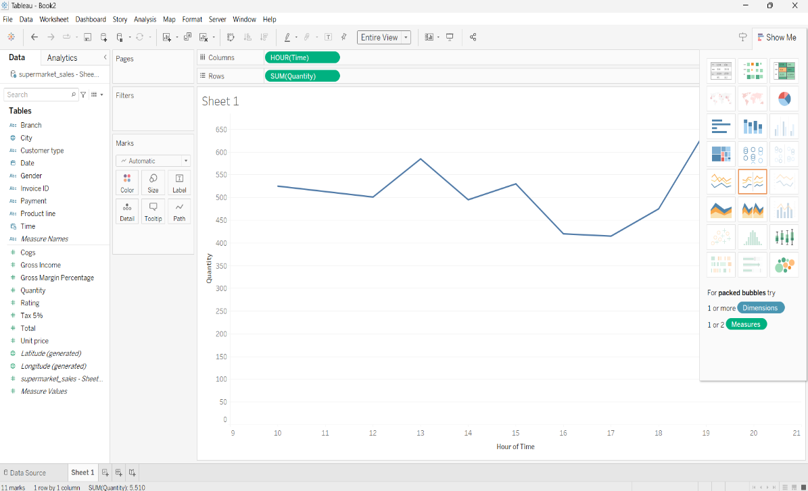

**BUBBLE CHART:**

